Appointment Scheduling

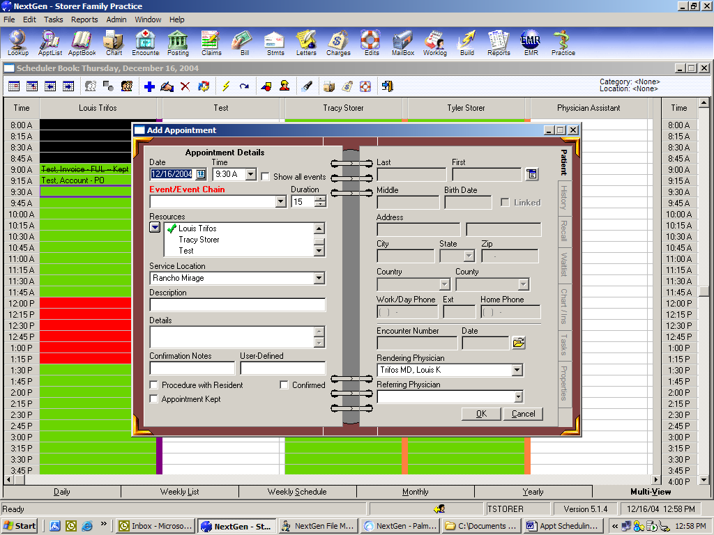

Fields
- Date: defaults date from the appointment book
- Time: defaults time from the appointment book
- Show all Events: To show all events, not just category specific
- Event/Event Chain: choose the appointment type
- Resources: the resource(s) indicated with a check mark are those resources that the appointment will be scheduled for.
- Service Location: the Service Location should default from the appointment book or may be entered manually. *This field will only display if there are multiple Service Locations associated to the Practice.
- Description: the description is the information that will display on the appointment book. After completing a patient lookup, the patient’s name will default into this field. If User is creating a non-patient appointment, then the information regarding the appointment may be entered in this field.
- Details: the details of the appointment, such as notes, instructions etc. This will print on the fee ticket. This will not display on the appointment book.
- User Defined 1 and 2: user defined fields set up in Practice Preferences. These are free form text fields that may be used to track information that is not already associated to the appointment These may be set to display on the appointment book Daily view, in the User’s Scheduling preferences.
- Procedure with Resident: if procedure is with a resident. Does not affect anything else in the system
- Confirmed: if this is checked, a telephone icon will display next to the patient’s name on the Daily View on the Appt Book
- Appointment Kept: when checked, indicates that the patient presented in the office for the appointment. *If a visit is created from the appointment,(checkin) then the system will automatically flag the appointment as “kept” If this is not checked, the system will automatically “No Show” the patient’s appointment at the close of the day.
- Demographic Fields: when scheduling a patient appointment, use the Patient Lookup function by clicking on the “Norton” button and choosing Lookup.
- Visit Number/Date: if a visit is created from the appointment, the visit number and date associated will display
- Rendering/Referring Physician: if the rendering and/or referring are entered, they will default to the Create Visit window when creating a visit from the appointment

Side Tabs
- Patient Info: patient demographic information
- Appt History: history of this patient’s appointment
- Recall: Add or displays any recall plan that the patient is participating in
- Wait List: Add or display wait list items
- Chart/Ins: displays the 4 User Defined fields on the patient’s chart if those fields are populated under the Demographic Tab/Chart Details Displays insurance and any authorizations attached to those insurances. User may add insurance to the patient or relationship here. User may attach or view authorizations here to an existing insurance.
- Tasks: Add or displays any appointment tasks attached to this patient.
- Properties: tracks the User that scheduled and modified the appointment

To Schedule an Appointment:

Open the appointment book by clicking on the “Appt Book” icon. Select the resource, the date, and time for the appointment by clicking on the time slot. Right click next to the time slot in the white are and choosing the option for “New”. Fill out fields on the Left side of the screen.

Attaching a patient.
On the Right side of the screen, click on the Norton Button and select “Lookup”
Search for patient by name, Social Security number etc. *Always search at least two times for a patient in order to avoid duplicate patient records. Click on Find.

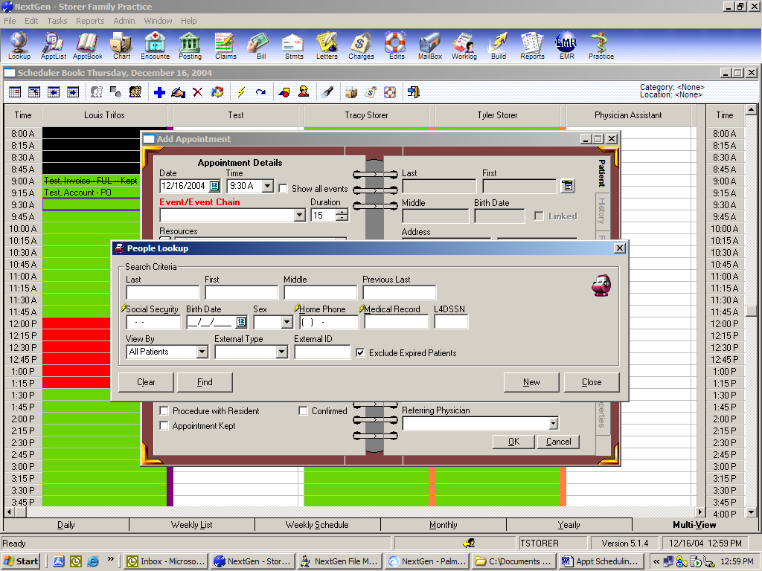

If patient is found in NextGen, double click on the record. This will display the People Maintenance screen for the patient. Verify information and add missing information or change incorrect information. Click on OK.

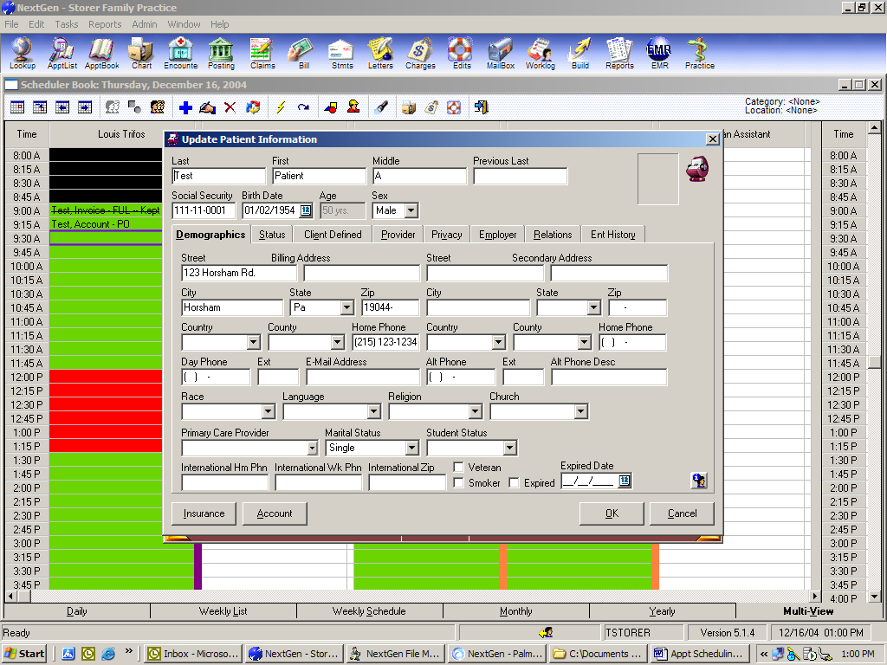

If the patient is not found in NextGen, a message will display “No records were found”. Click on OK to close the box. Click on the “New” button and perform a pre-registration for the patient. Complete all fields, as indicated. Click “OK”.

Verify that all information on the Add Appt window is correct. Click “OK”.

Appointment is now scheduled.
